Alexander Shah

MSCS 630

HW0 – Proof

Java, javac, git proof:

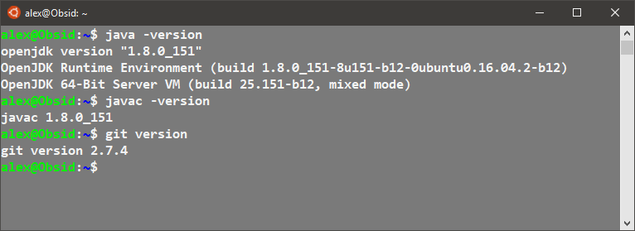

Github account, repo, collaborator proof:

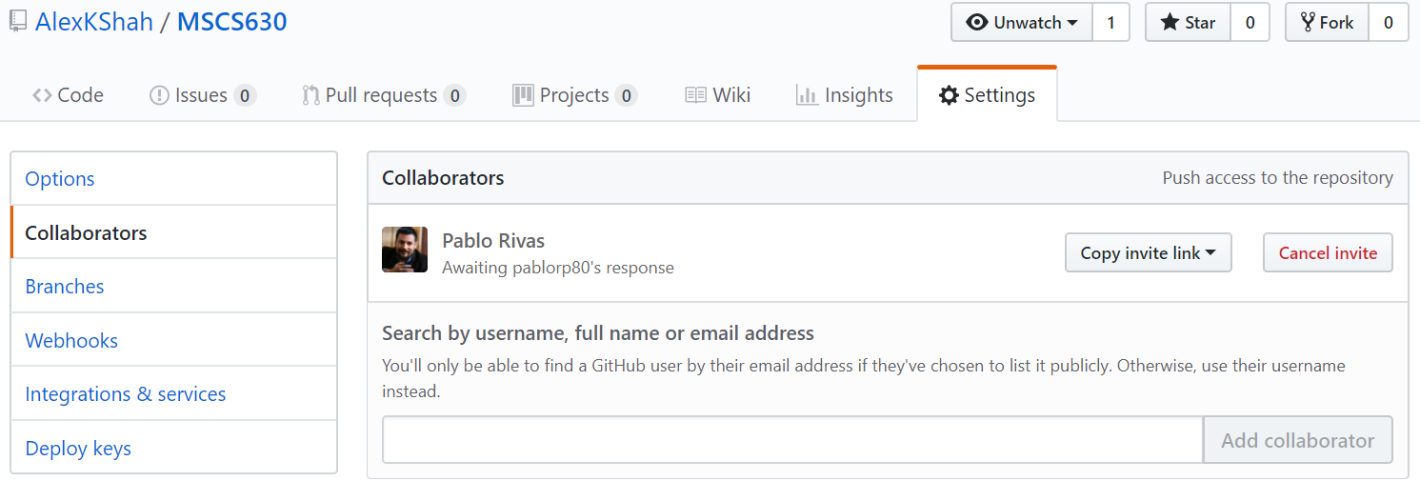

Repo Link:

https://github.com/AlexKShah/MSCS630.git